**Course name : Project Management of Complex system (EM 612-A)**

**Project Name – Univ AI1**

**Group members :-**

Annie Renita

Basel Ghaly

Amey Naik

Akhilesh Wagh

Contents

Introduction 3

Executive Summary

Problem Statement 4

Project Charter 5

Work Breakdown Structure 6

Gantt Chart 7

Meeting minutes 8

# Executive Summary

Getting a degree has become a customary thing in-order to get a decent salary in today’s world but finding a university to get the best opportunities for you to enhance your skills and get placed at your dream university with all the facilities, coursework and other demographics of your choice. Many students and parents find it difficult to find information about different universities and their pros and cons. It is a hassle to juggle around between different university sites to find information that is relevant to your requirements to find your perfect university.

Finding a university that will benefit your career is of great priority for many individuals and helping you find all the information and resources to achieve that is the main goal. There are a lot of factors that students and parents look for while choosing to apply to various universities. Some of them are a s follows courses available at the university, course curriculum , university’s world ranking, university’s state ranking, faculty, public or private university, fee structure, types of degrees provided at the university, job placements, internship opportunities, crime rates near the university, census of the area (whether it’s too crowded or not), etc. Our application is a one stop portal where users can find all the information about the universities and other factors that will help them to decide which universities they can apply to.

University AI1 which means “University all in 1” is a community-driven and community-oriented application that enables its users to view universities and get an overall analysis of them based on various features. Also, it enables its users to review, comment and rate the schools and help to improve all the students and parents. It is easy to use and user friendly. The application can be used by people of any age ; students applying for undergraduate, graduate or phd, parents, etc.

# Problem Statement

* Finding a university to get the best opportunities for you to enhance your skills and get placed at your dream university with all the facilities, coursework and other demographics of your choice. Many students and parents find it difficult to find information about different universities and their pros and cons. It is a hassle to juggle around between different university sites to find information that is relevant to your requirements to find your perfect university.
* Need for a source verified review system about the universities, will be helpful for students and parents all around the world. Data integrity is an important factor that is prioritized in the design of the application.

**Ranking** 

# 

# 

# 

# 

# 

# 

# 

# 

# Project Charter

**Project name:** University All in One

**Background and justification:** University all in one is a project dedicated to help students and parents all over the world to find the perfect university of their choice. It is a design for an application which will be helpful for students to access all university related information at one place.

**Project Objective:**

* To make use of agile software development model.
* To develop design for an application to access all university related information on a single application.
* To help in comparison between universities.
* To add university related information like ranking and reviews of the university, undergraduate and graduate programs offered, geographical location, crime rate of locality for each university.
* To design easy to use application which should be suitable for all age groups.

**Project Deliverables:**

1. Context diagram
2. Use case diagram
3. Choreography diagram
4. Use Case description
5. Data dictionary
6. Class diagram (Without method)
7. Sequence diagram
8. Interface design
9. Database design
10. Complete class diagram (with methods)
11. Software design

**Project Scope:**

* Design for an application for students at access all university related information at one place.
* Review system which will help the students choose the university based on reviews from students studying in the university.
* GUI system for application.
* Map displaying all universities in New Jersey and New York City.
* Future Scope: Expanding to other states of America, consulting services for students, university tie-ups, comparison between selected universities.

Future Scope: Actual development of the application

**Project Success Criteria:** The project will be considered successful if students and parents of all age groups from all over the world will start using the application for comparing and selecting university.

**Project Sponsor:** Stevens Institute of Technology

**Project Stakeholders:**

1. Dr. Feng Liu - Advisor
2. Annie Renita - Project Manager / App designer
3. Basel Ghaly - App designer
4. Amey Naik - App designer
5. Akhilesh Wagh - App designer

# Work Breakdown Structure

1. Phase 1 : (Milestone 1)

1.1 Initiation

1.1.1 Defining scope and project deliverables

1.1.2 Scope analysis

1.1.3 Identifying stakeholders

1.1.4 Project charter

1.2 Project management

1.2.1 Requirement gathering

1.2.2 Requirement analysis

1.2.3 Project estimate

1.2.4 Planning

1.2.4.1 Scheduling

1.2.4.2 Resource planning

1. Phase 2 : (Milestone 2)

2.1 Design - I

2.1.1 Context Design

2.1.2 Use case diagram

2.1.3 Choreography diagram

2.1.4 Use case description

1. Phase 3 : (Milestone 3)

3.1 Design -II

3.1.1 Data dictionary

3.1.2 Class diagram (without methods)

3.1.3 Sequence diagram

3.1.4 Interface diagram

3.1.5 Database diagram

1. Phase 4 : (Milestone 4)

4.1 Design - III

4.1.1 Complete class diagram (with methods)

4,1.2 Software design

4.2 Review

4.2.1 Adaptation of any scope changes

4.2.2 Analyze the impact on modules

4.2.3 Review the project

4.2 Delivery

4.3.1 Package creation

4.3.2 Deliver the package (report)

# Gannt Chart

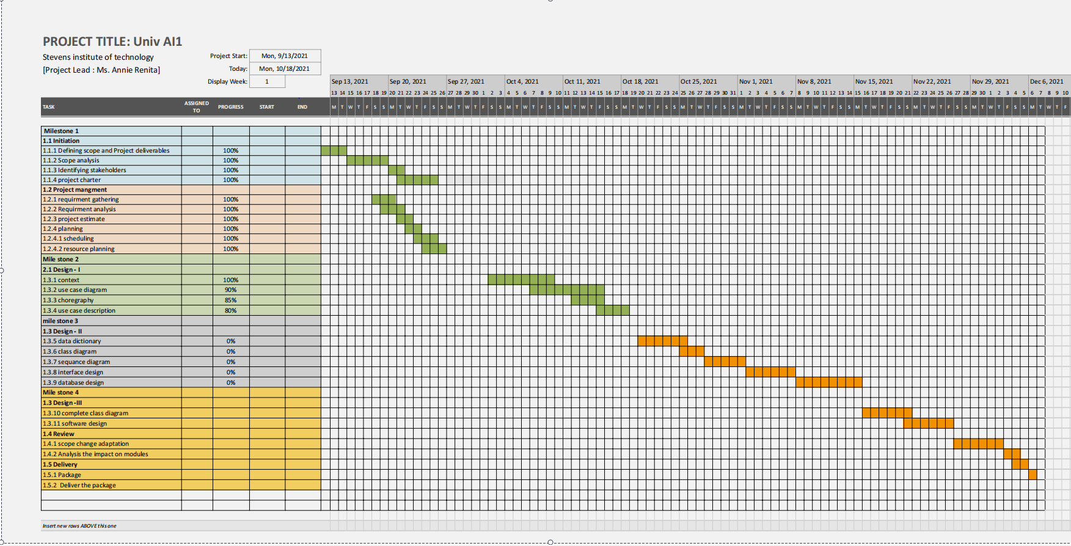

Meeting Minutes :

| Meeting 1 | |
| --- | --- |
| Meeting Topic | Initial meetup. |
| Meeting Time | September 18th 2021 |
| Attendees | Annie, Akhilesh, Amey |
| Meeting Content | Brainstorming the final topic of our project from the given options. We decided to look for more options apart from the ones provided by the professor. |
| Meeting Conclusion | We combinedly decided to work on an interesting project where we could help a large number of students in their registration of masters process. |
| Person Responsible |  |

| Meeting 2 | |
| --- | --- |
| Meeting Topic | Brainstorming & Discussion |
| Meeting Time | September 25th 2021 |
| Attendees | Annie, Akhilesh, Amey, Basel |
| Meeting Content | After the initial meeting, we collected data about the project we wanted to work on, put it all together and decided to have a word with the professor to discuss the scope of our project. |
| Meeting Conclusion | Professor suggested a few changes depending on the available time and feasibility of things. We finalized the topic accordingly and started working on creating an outline. |
| Person Responsible |  |

| Meeting 3 | |
| --- | --- |
| Meeting Topic | Plan of action. |
| Meeting Time | October 2nd 2021 |
| Attendees | Annie, Akhilesh, Amey, Basel |
| Meeting Content | After the last meeting, we had a better idea about the duties we needed to execute, and we distributed tasks accordingly. We worked on the use case diagram, context diagram, case description, and approach that we would be using. |
| Meeting Conclusion | Categorized the duties according to the people in the group and their expertise. Finalized all the diagrams, so we could proceed to methodology. |
| Person Responsible |  |

| Meeting 4 | |
| --- | --- |
| Meeting Topic | Choreography Diagram |
| Meeting Time | October 9th 2021 |
| Attendees | Annie, Akhilesh, Amey, Basel. |
| Meeting Content | We discussed the milestone 1 report where we had to submit the entire layout of the project. We created a power-point presentation to elaborate all the parameters we would be including in our project. We displayed our stakeholders and sponsors. |
| Meeting Conclusion | All the diagrams were complete, and the milestone 1 project report was completed successfully. |
| Person Responsible |  |

| Meeting 5 | |
| --- | --- |
| Meeting Topic |  |
| Meeting Time | October 17th 2021 |
| Attendees | Annie, Amey, Basel |
| Meeting Content | Reviewing the work done, |
| Meeting Conclusion | Milestone 2 report was completed successfully. |
| Person Responsible |  |